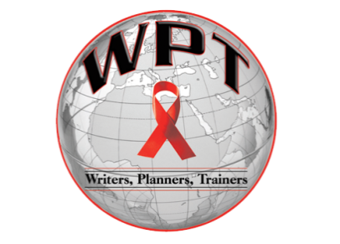

1405 State Street / East St. Louis, IL 62205

NEWS RELEASE

February 7, 2013 Contact Information:

Carlos Reyes-

Phone: 312-568-6591

Email: Reyes87@wptcares.com

HIV in 3D

An in-depth look at our alter egos

East St. Louis, Ill. – Writers, Planners, Trainers, a nonprofit private agency, will begin its 2013 National Black HIV/AIDS awareness month campaign “HIV in 3D-An in-depth look at our alter egos” with a kickoff seminar on Thursday, Feb. 7. The focus of the seminar is to educate the community on high risk behaviors that may lead to contracting HIV.

The seminar will be held at the Writers, Planners, Trainers headquarters in the Mallorie J. Mahr Youth Empowerment Center, 1405 State St. It will include presentations on HIV sexual risk behavior, substance abuse, mental health and recent developments in efforts to find a cure. Presenters include special guest Jay Manuel of American Next Top Model, the executive director of Writers, Planners, Trainers, Harold Lawary, and a community youth mentor and Speech Communication and Community Health student from Southern Illinois University Edwardsville, Carlos Reyes. “These activities and seminars are to help our community grow and learn great ways to reduce the risk of catching HIV and to prevent the spread of HIV,” said Lawary. “This can only be stopped or controlled if we come together as one. Educating is key.”

-more-

Page 2 of 2

The seminar will take the audience on a journey through the minds of three MSM/TRANGENDER community members and introduces them to the alter ego that has taken shape as a result of living their unique lives. “This will give some insight on how social determinants shape us mentally, how our mental issues develop a personality of their own and how the physical manifestation of these alter egos influence our sexual risk behavior,” explained Reyes.

The seminar will also include interactive activities and educational breakout sessions on high sexual risk behavior, as well as group discussions on how to effectively practice safer sex techniques. There will also be an alter ego photo exhibit with a caption that speaks to the conscious of the viewer. “It is said that a picture is worth a thousand words,” said Manuel.

For more information, please contact Carlos Reyes at (312) 568-6591 or email at reyes87@wptcares.com

Writers Planners and Trainers, WPT was founded in March of 2003. The agency is a private nonprofit corporation in the state of Illinois operating as a charitable corporation. The mission of the agency is to advocate, educate and act as a resource for the East St. Louis metropolitan area, with particular regards to supportive services and resource development for the area most vulnerable populations. The organization’s programs includes seminars, workshops, Confidential HIV counseling, Testing and Referral services.

-###-

